SIMATS ENGINEERING
ASSESSMENT TOOL 2
Course Code | CSA51
Course Name | Cryptography and Network Security
Course Outcome (CO2) | Analyze Public Key crypto system strategies using RSA and Key Exchange for Encryption algorithm to strengthen information security. (BL4, BL5)
Scenario-Based | 20%
Total Marks | 50
Questions Attempted | Q3 – Key Exchange in an Unsecured Network; Q5 – Cryptography for IoT Devices
Annexure A – Code of Conduct
I M. Mokshith Reddy - 192372373 certify that this submission is my original work and that I have adhered to the guidelines specified for this assessment.
I understand that any violation of academic integrity rules will result in disciplinary action.
Signature of the student: M. Mokshith Reddy

3. Key Exchange in an Unsecured Network
Scenario: Two users want to establish a secure communication channel over a public network using Diffie-Hellman key exchange. However, the network is vulnerable to attacks.

A. Explain how the key exchange works in this scenario
Diffie-Hellman (DH) allows two users, A and B, to derive a shared secret key over a public channel without ever transmitting the key itself. The process proceeds as follows:
- Both users publicly agree on two values: a large prime p and a generator (primitive root) g. These values do not need to be kept secret.
- User A privately chooses a secret integer a, and computes the public value A = g^a mod p.
- User B privately chooses a secret integer b, and computes the public value B = g^b mod p.
- A and B exchange their public values (A and B) over the public/insecure network. Since the private exponents a and b are never sent, an eavesdropper only sees p, g, A and B.
- User A computes the shared key as K = B^a mod p, while User B computes K = A^b mod p. Both expressions simplify to K = g^(ab) mod p, so both parties independently arrive at the identical shared secret.
- This shared key K is then used as the symmetric key for encrypting the actual data exchanged between A and B.
The security of this scheme rests on the Discrete Logarithm Problem: given g, p and A = g^a mod p, it is computationally infeasible for an attacker to recover a when p is a sufficiently large prime.
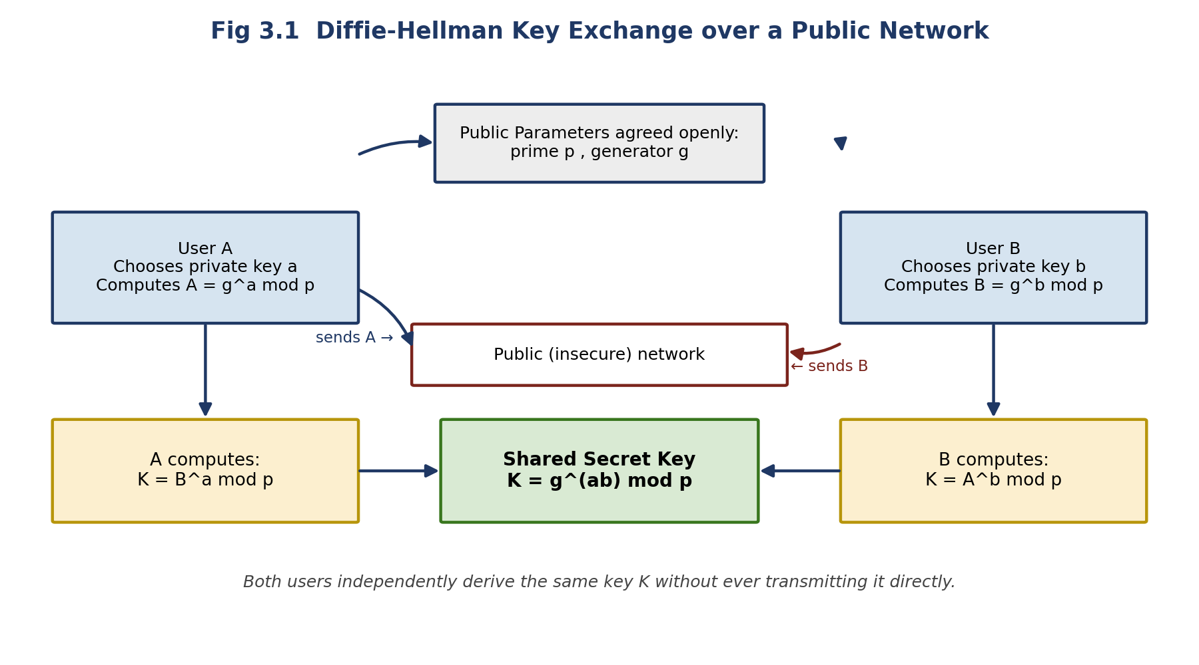
Fig 3.1: Diffie-Hellman key exchange establishing a shared secret over a public network

B. Identify a possible security threat and suggest a solution to mitigate it
Security threat — Man-in-the-Middle (MITM) Attack:
- Plain Diffie-Hellman authenticates neither party; it only guarantees that the two ends of a given exchange share a common secret — not who that other end actually is.
- An attacker, Eve, positioned on the public network can intercept A's public value and forward her own public value to B instead, and do the same in the other direction with B's public value sent to A.
- A ends up sharing a secret key with Eve while believing it is shared with B, and B ends up sharing a different secret key with Eve while believing it is shared with A.
- Eve now holds both keys and can silently decrypt, read, modify, and re-encrypt every message passing between A and B — a complete break of confidentiality and integrity without either party detecting it.
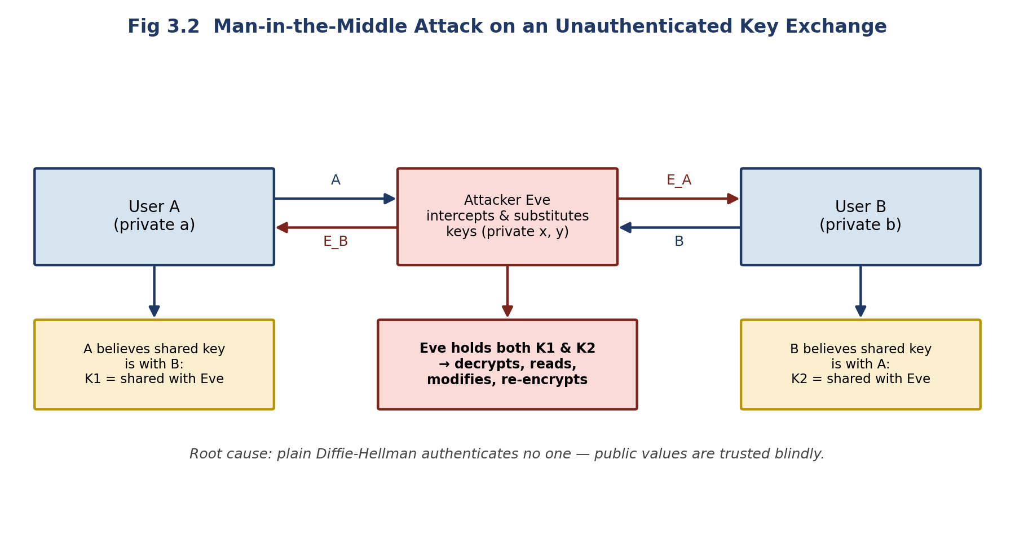
Fig 3.2: Man-in-the-Middle attack exploiting the lack of authentication in plain Diffie-Hellman
Mitigation / Solution:
- Use Authenticated Diffie-Hellman, such as the Station-to-Station (STS) protocol, where each party digitally signs its public value so the other side can verify its authenticity before trusting it.
- Bind public keys to verified identities through a Public Key Infrastructure (PKI) using digital certificates issued by a trusted Certificate Authority (CA).
- Deploy the exchange inside an authenticated protocol such as TLS/SSL, which combines ephemeral Diffie-Hellman (ECDHE) with certificate-based authentication, giving both confidentiality and protection from MITM attacks.
- As an additional safeguard, out-of-band verification (e.g., comparing key fingerprints over a separately trusted channel, such as a phone call) can detect a substituted key.

5. Cryptography for IoT Devices
Scenario: A smart home system uses low-power IoT devices that need secure communication. The designer must choose between RSA and Elliptic Curve Cryptography (ECC).

A. Analyze the constraints of IoT devices
Smart-home IoT devices (door sensors, smart bulbs, thermostats, cameras) are designed to be small, cheap, and long-lasting on limited power, which imposes several constraints on the cryptography they can run:
Constraint | Implication for Cryptography
Limited processing power | Low-end microcontrollers cannot efficiently perform heavy operations such as large modular exponentiation; algorithms must minimize CPU cycles.
Limited memory (RAM/flash) | Little space is available to store keys, certificates, and code; larger keys and bulky implementations may not even fit.
Limited battery / energy | Devices often run for months or years on a small battery; every extra CPU cycle spent on crypto directly shortens battery life.
Low network bandwidth | Protocols like BLE, Zigbee, or LoRa carry small packets; large keys/certificates increase transmission overhead and energy cost per message.
Physical exposure | Devices are often physically accessible to attackers, increasing risk of tampering and side-channel attacks; lightweight but robust key protection is needed.
Scale of deployment | A smart home (or larger deployment) may involve dozens of devices, requiring lightweight, low-overhead key management and provisioning.
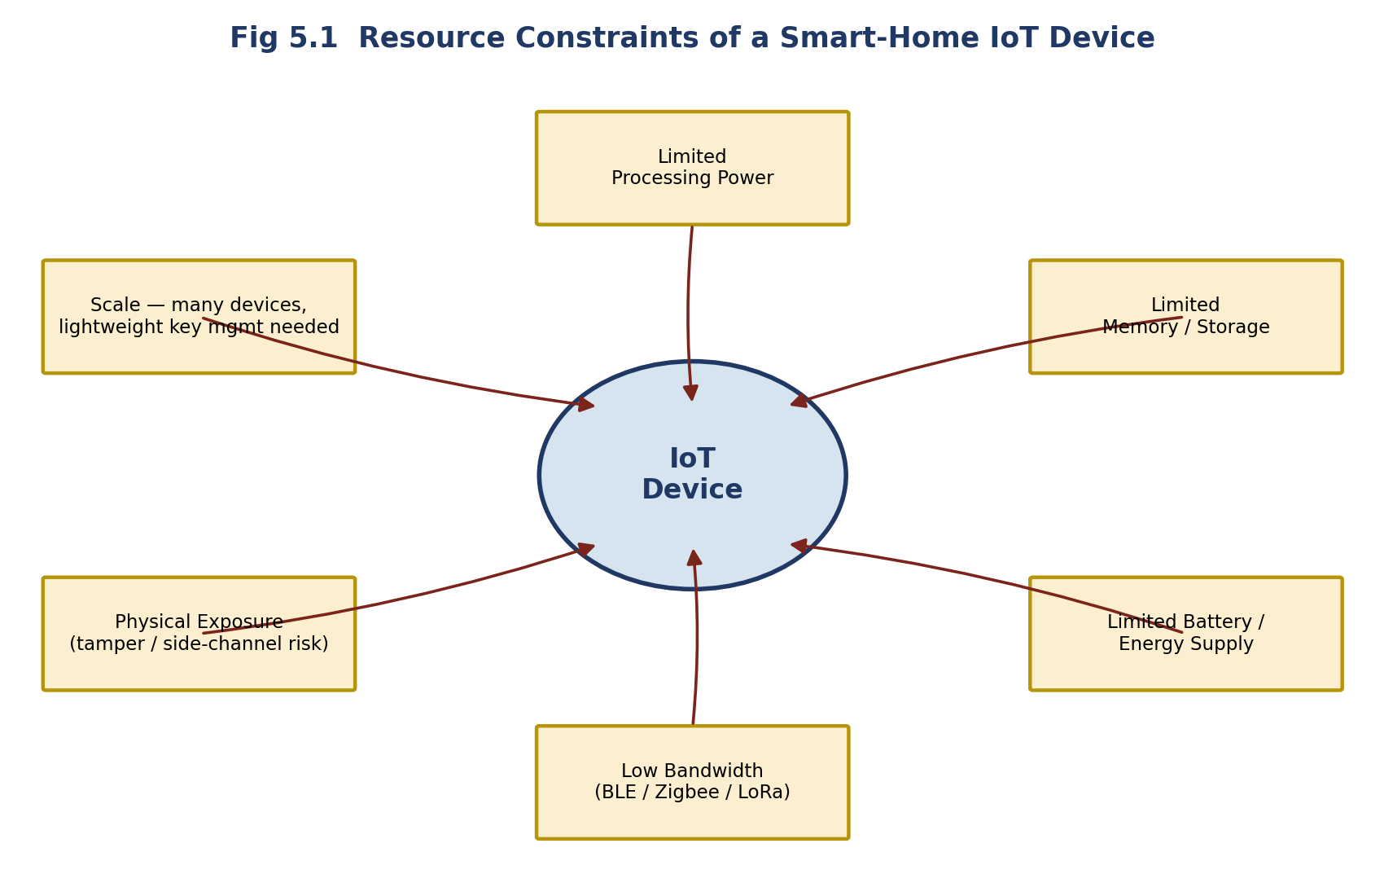
Fig 5.1: Key resource constraints faced by a smart-home IoT device

B. Recommend a suitable cryptographic approach and justify your answer
Recommendation: Elliptic Curve Cryptography (ECC) is the more suitable choice for this smart-home IoT scenario.
- Smaller keys for equivalent security: ECC achieves security comparable to RSA with a much smaller key — a 256-bit ECC key offers security similar to a 2048-bit RSA key. Smaller keys mean smaller certificates and less data to store and transmit.
- Lower computational cost: ECC's elliptic-curve point operations require far fewer processor cycles than RSA's large modular exponentiations at an equivalent security level, which matters greatly on constrained microcontrollers.
- Lower power consumption: Fewer computation cycles translate directly into lower energy draw per cryptographic operation, which helps battery-powered smart-home devices last longer between charges or replacements.
- Reduced bandwidth usage: Smaller keys and signatures reduce the size of handshake and authentication messages, which is valuable on low-bandwidth IoT radio protocols.
- Practical fit for scale: With many devices needing to be provisioned and managed, ECC's lighter footprint simplifies key storage and management across the whole smart-home deployment.
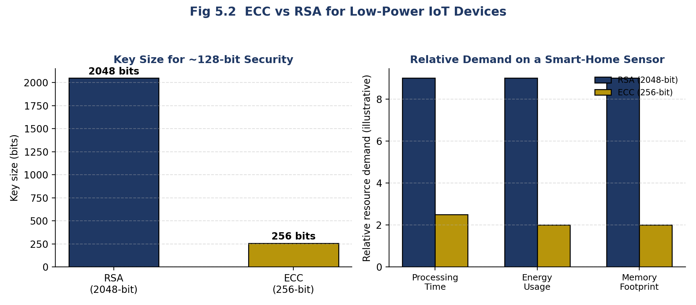
Fig 5.2: ECC vs RSA — key size and relative resource demand on a smart-home sensor
Overall Justification:
Given that smart-home IoT devices are constrained in processing power, memory, energy, and bandwidth, ECC's ability to deliver RSA-equivalent security with drastically smaller keys and lighter computation makes it the practical and efficient choice. RSA remains usable where devices have more processing headroom (e.g., a home hub or gateway), but for the low-power end devices themselves, ECC is recommended.
— End of Assessment —

